**WEEKLY PROGRESS REPORT**

**Sightline Capstone Project**

**Week 14**

**13 April 2019**

**Tai:**

**This week:**

* Install Ubuntu to create a MAVProxy command window.
* Set up the desired location which I chose Sightline’s address to set up the location.
* Run the command below to setup the SITL (software in the loop) simulation for quadcopter with based address at Sightline:

sim_vehicle.py -L Sightline --console –map

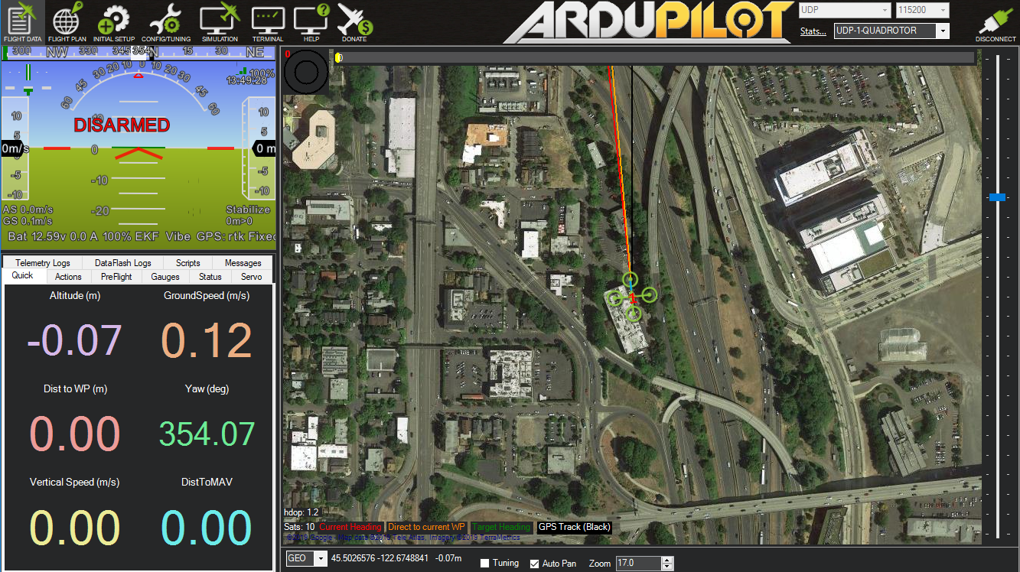

* Test the function of the simulation mode which include arm/disarm, speed, wind, acceleration, gps, failsafe and flight mode.
* Try to test the mission feature on the mission planner.

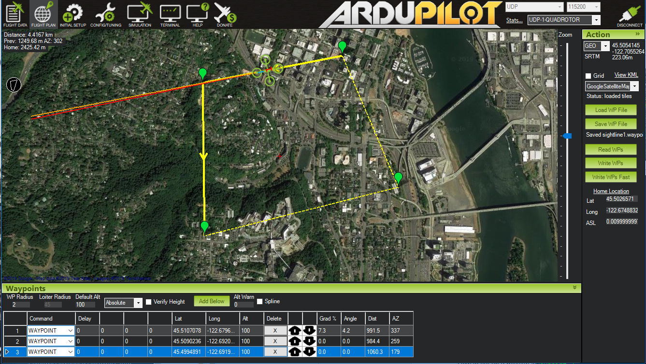

* There are a few problems with the simulation which based on the limitation of the simulation model such as can’t change the speed, only arm the vehicle in the guided mode, and lack of flight mode such as stabilize, position hold.

**Next week:**

* There is a potential to develop the simulation along with the real serial devices which might be helpful in the develop a serial communication between sightline hardware and the Mission Planner.
* Other feature could be tested such as virtual optical flow sensor and virtual range finder which would be helpful in precision landing technique.

**Question:**

**Kimball:**

**This Week:**

* Made the following changes to SLA1500 CAM REV 5.0:
* Repositioned DF12B 50 pin connector based on dimensions and SLA1500 gerber file from Sightline
* Rerouted all connections to DF12B
* Repositioned power supplies/ IO connectors, rerouted all traces
* Repositioned power grid as needed
* Changed all signal traces to 6 mil traces
* Ensured signal trace spacing >12 mil where possible
* Replaced all 0201 components with 0402 components, rerouted traces
* Resized all vias
* Tented vias under components/ in trouble areas
* Repositioned ARO134CS to optical center (-0.96, -2.0um), rerouted all traces
* Created SLA1500 CAM REV 6.0 document/ pushed changes to Github
* Generated SLA1500 CAM REV 6.0 BOM
* Meeting with Dr. Kravitz

**Next Week:**

* Review Layout REV 6.0 with Sightline team
* Make final adjustments to Layout
* Generate Gerbers for Manufacturing

**Comments/Questions:**

None at this time